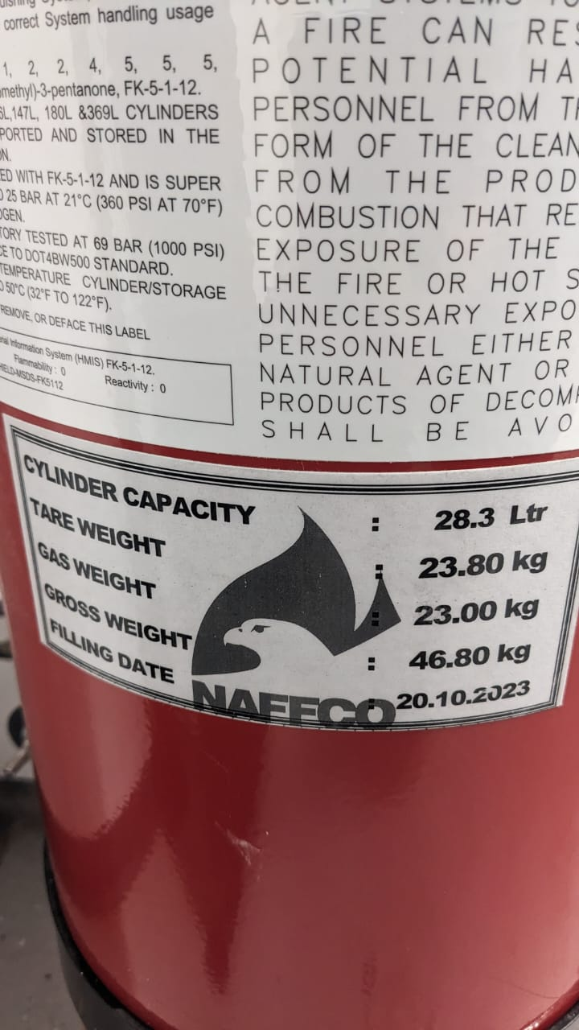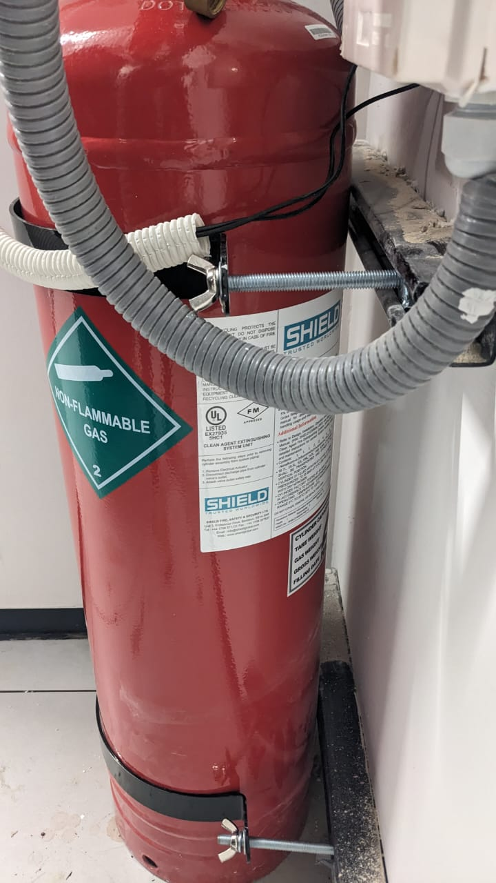**BELOW CYLINDERS PICTURES SHOW CURRENT LOCATION**

**INSTALLED AT 18TH FLOOR IT ROOM**

**INSTALLED AT 19TH FLOOR IT ROOM**

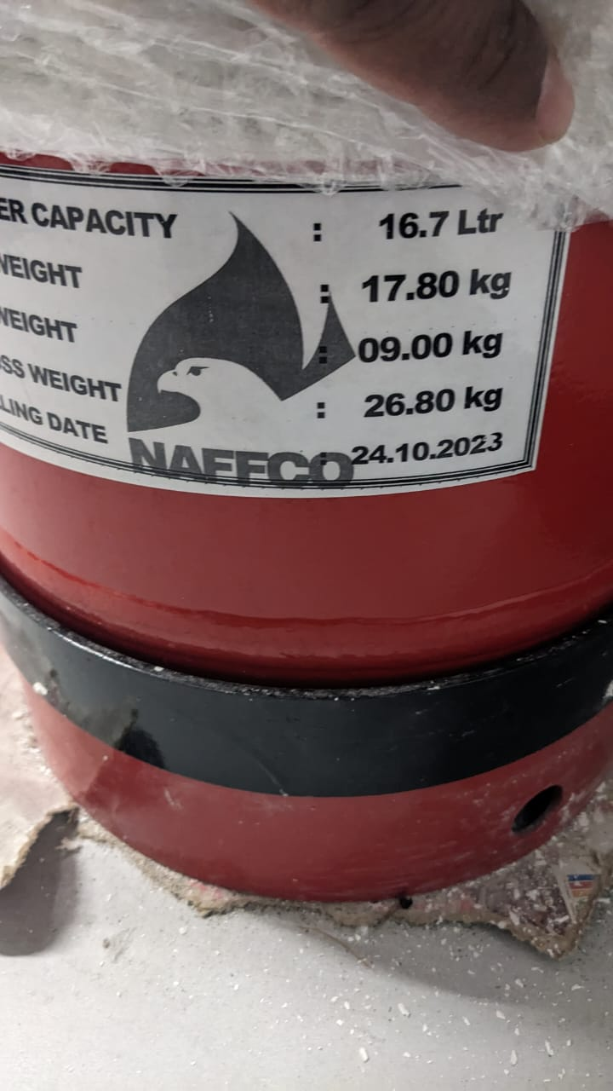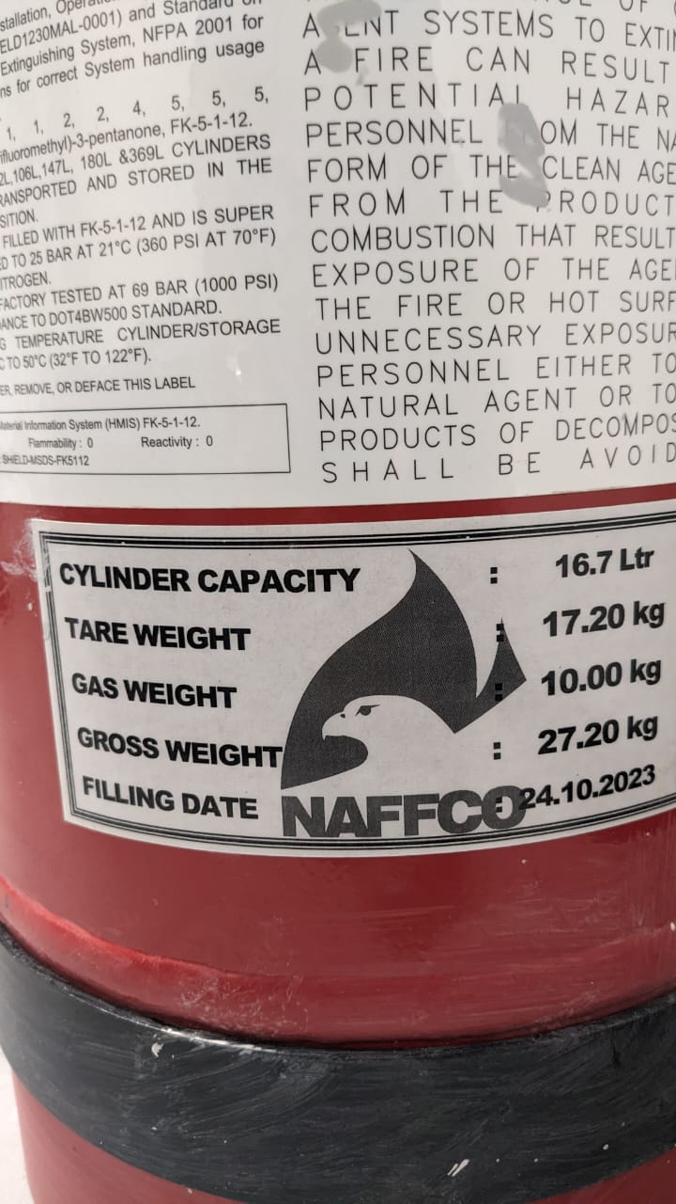

**INSTALLED AT 18TH FLOOR UPS ROOM**

**INSTALLED AT 19TH FLOOR UPS ROOM**